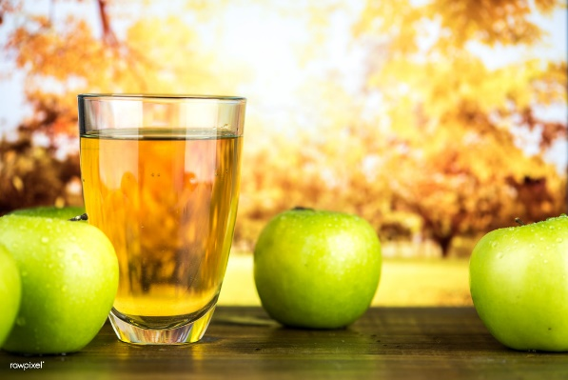

Galgate Apple Festival
This year we are able to celebrate the Apple Harvest together, but we are still offering delivery of homemade pies, crumbles and cakes alongside our apple juice for those who pre-order.
There will also be a stall outside the Church with a wider selection of goodies and lots of activities for the children as well as a chance to assist with the apple pressing.
Please complete the following order form and return it to Church, the Vicarage, on Highland Brow, or Chapel House, Chapel Lane, by Sunday October, 10th with cash or cheque (made payable to St John’s PCC) or pay online via BACS.
Name – Ellel St John’s PCC Business Account Sort code 01-54-90 Account number 00013021
Name ……………………………………………………….
Address ………………………………………………………………………………………………………..
……………………………………………………………………………………………………………
Phone Number ………………………………………………………………….
Suggested Donation Suggested Donation
………… Apple pie for 2 £2-00 ………. Family Apple Pie for 4 £3-00
………… Small Apple Crumble £2-00 ………. Family Apple Crumble (4) £3-00
.……… Apple Juice £2-50 ………. Apple Chutney £2-50
……….. Apple Spice Cake £3-00
Ring Helen for more details on 07973 203233.
Collection ……………… or Delivery ………………………
Any times you are not available for delivery? ………………………………………….

Galgate Apple Festival
This year we are able to celebrate the Apple Harvest together, but we are still offering delivery of homemade pies, crumbles and cakes alongside our apple juice for those who pre-order.
There will also be a stall outside the Church with a wider selection of goodies and lots of activities for the children as well as a chance to assist with the apple pressing.
Please complete the following order form and return it to Church, the Vicarage, on Highland Brow, or Chapel House, Chapel Lane, by Sunday October, 10th with cash or cheque (made payable to St John’s PCC) or pay online via BACS.
Name – Ellel St John’s PCC Business Account Sort code 01-54-90 Account number 00013021
Name ……………………………………………………….
Address ………………………………………………………………………………………………………..
……………………………………………………………………………………………………………
Phone Number ………………………………………………………………….
Suggested Donation Suggested Donation
………… Apple pie for 2 £2-00 ………. Family Apple Pie for 4 £3-00
………… Small Apple Crumble £2-00 ………. Family Apple Crumble (4) £3-00
.……… Apple Juice £2-50 ………. Apple Chutney £2-50
……….. Apple Spice Cake £3-00
Ring Helen for more details on 07973 203233.
Collection ……………… or Delivery ………………………
Any times you are not available for delivery? ………………………………………….

